Hello Red Baron’s!
Congratulations with the new Bunch of Barons. Ten new siblings is amazing, Scooby is so proud to be a Big Sis now. As big sister, she now has to set an example for the little ones, so here we have some pictures of how to be a big baron.
Good luck in these busy days,
Roland, Viviane and Scooby “big sis” Doo

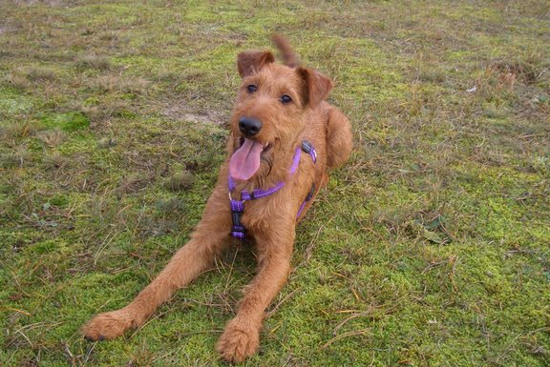 “Hey little ones, welcome to the club!”
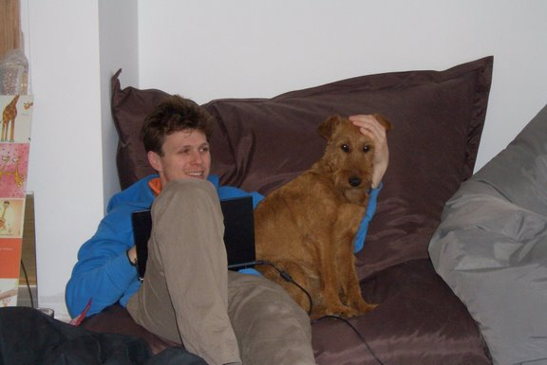 “Remember: two legs is your friend.”
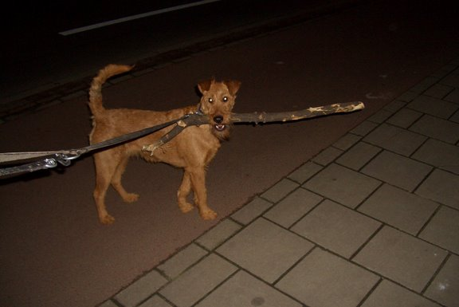

“Sometimes you need to bring them a present, make sure it is a big one”
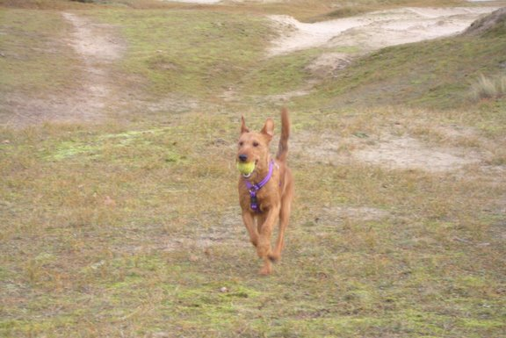 “Catching balls keep you fit and fast”
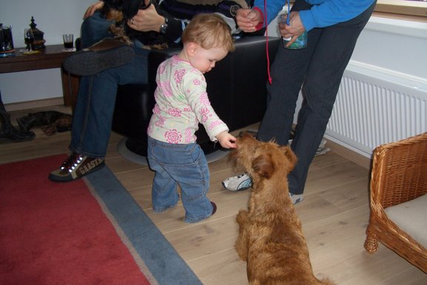

“Don’t beg for goodies yourself, you get more if you play it cute.”
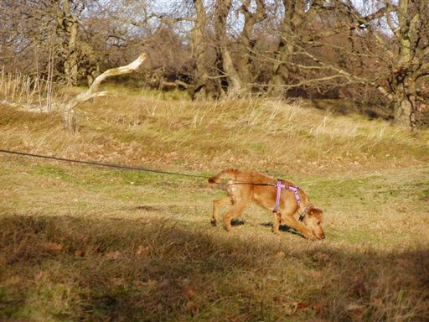

“A Big Baron comes to the rescue, with track and trail you always find your way.”
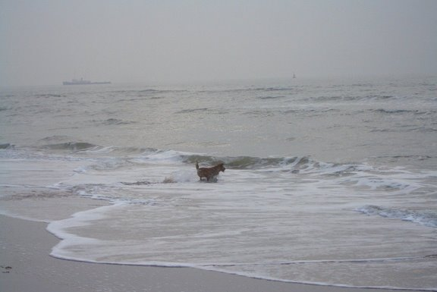

“As a real North Sea Terrier, sometimes you miss your family so much, you even want to swim back.”

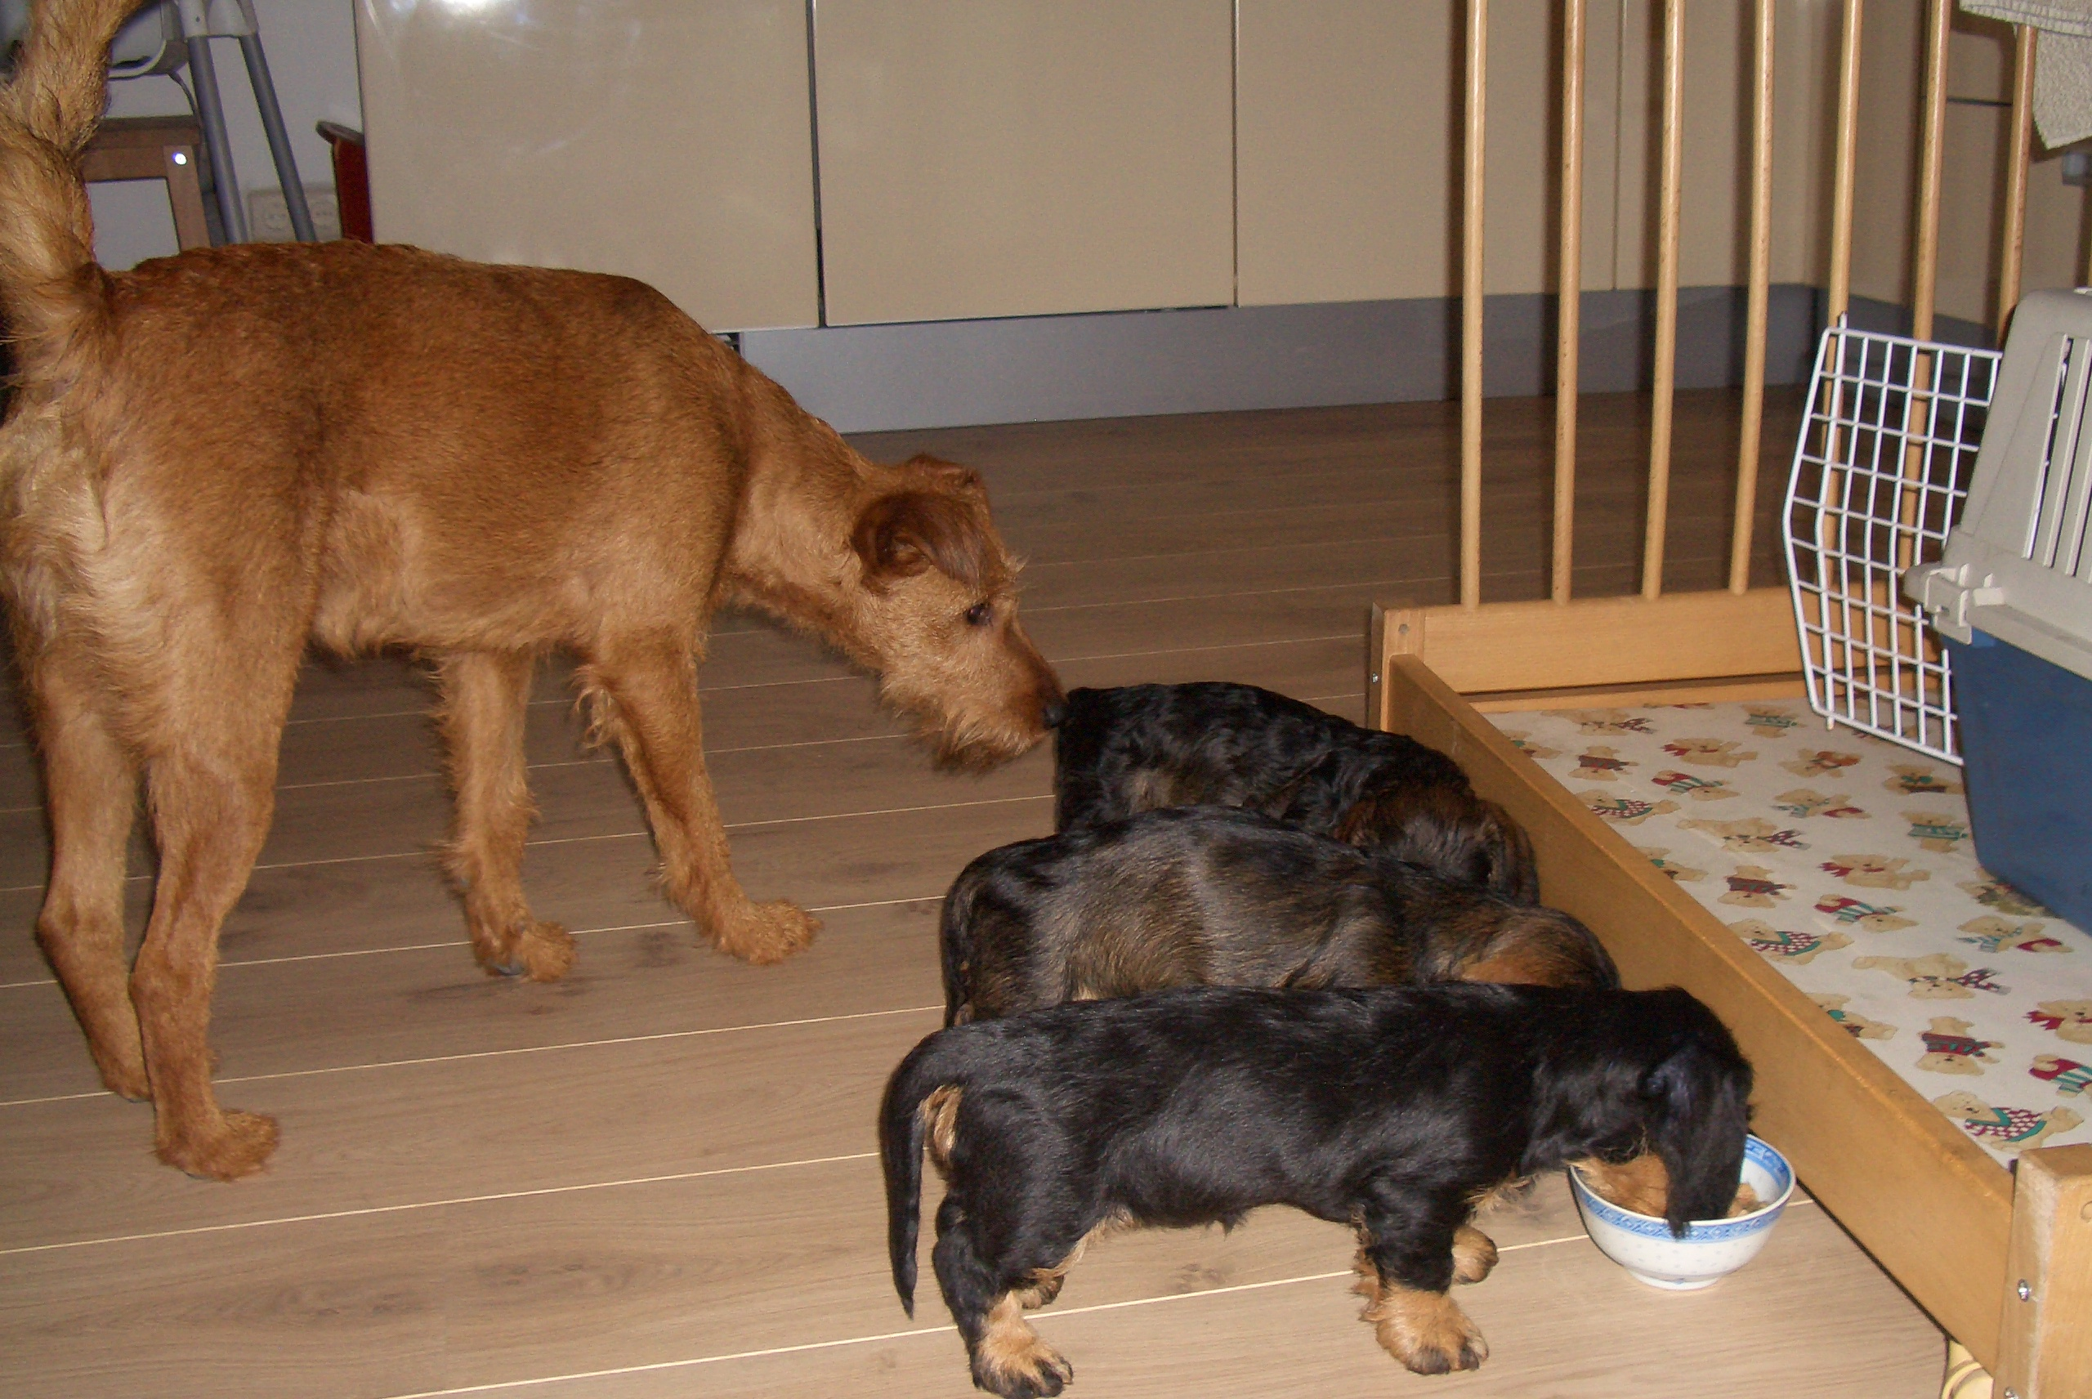

“I always keep an eye to the little ones, so you better do well!”

